Project Part 3

* Download Dataset to my computer.
* Now we are going to use hive so we have to load data into hive first.
* Open Putty.

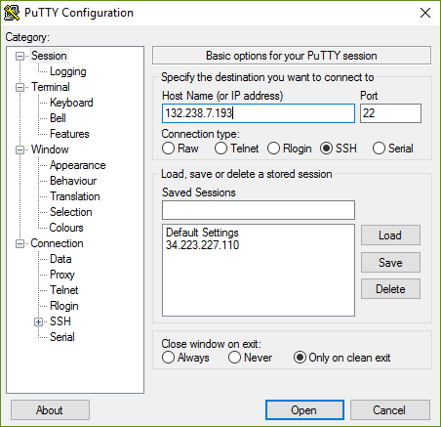

* Connect to FDU Cluster.

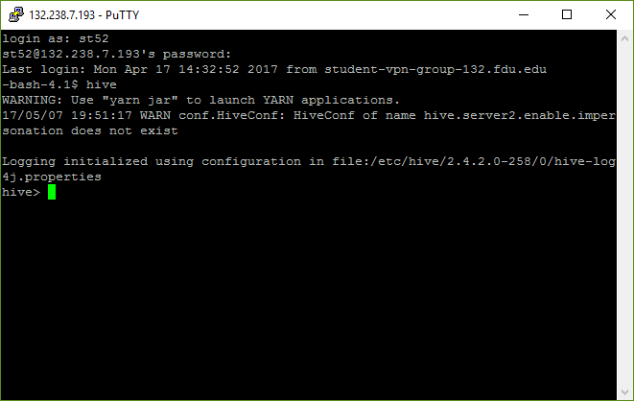

* Used Command beeline and !connect jdbc:hive// to connect to hive using my credentials.

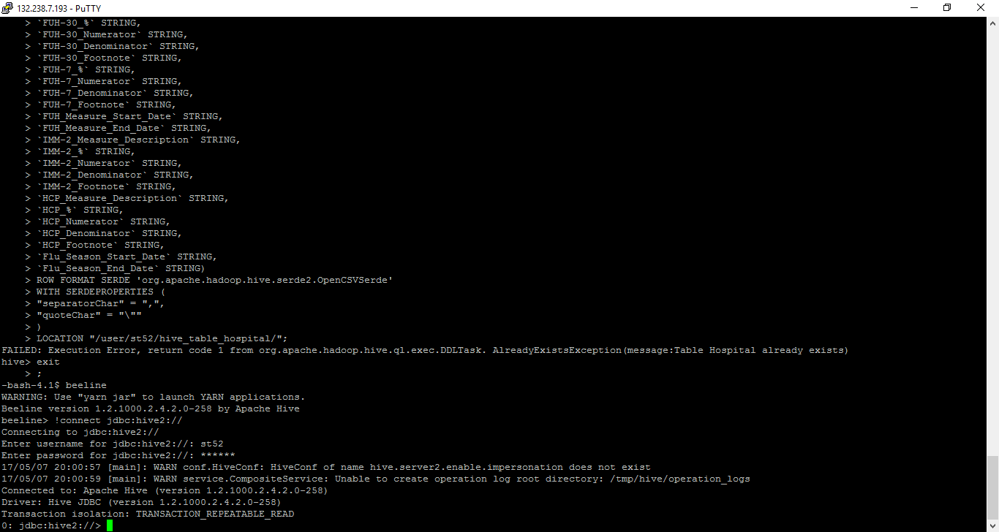

* Create Database st52_tableau.

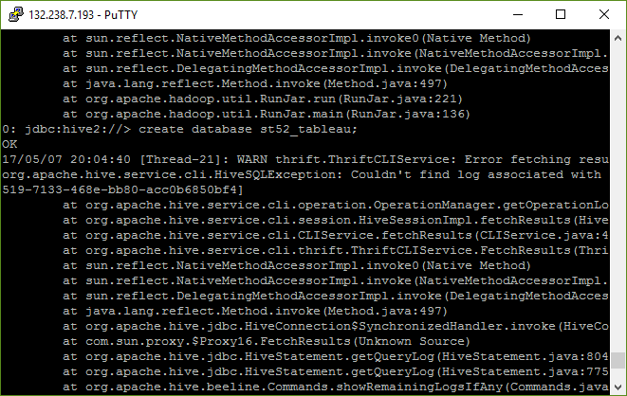

* Use Database that we have created.
* Now execute the query that were provided in hive.
* And Load data into it. To do that Upload file to Ambari first in my user directory.

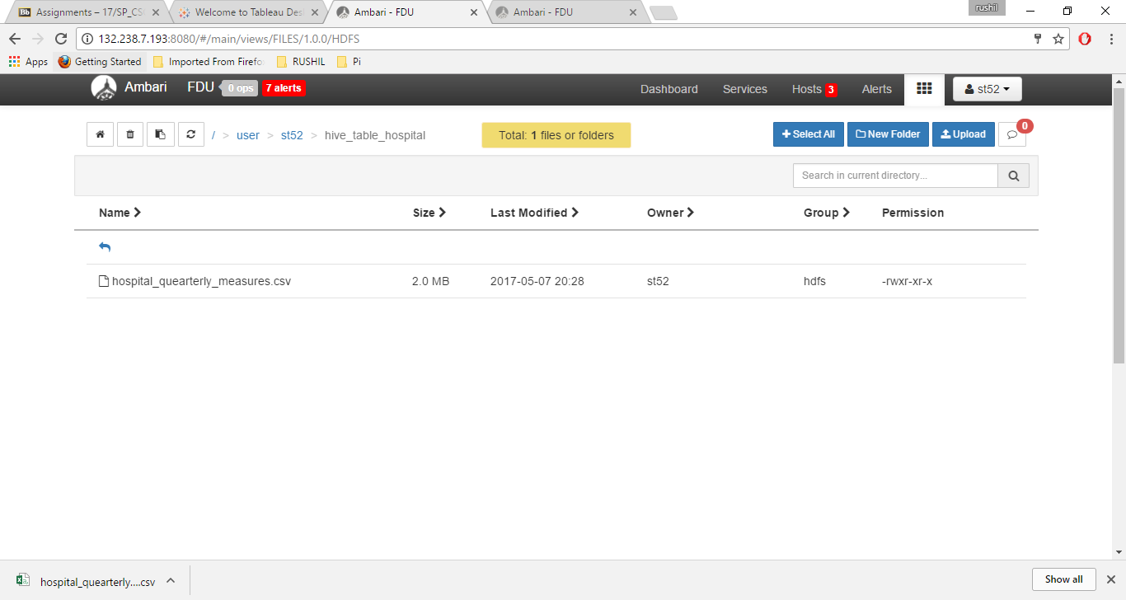

* Now Open Tableau.
* Add New Connection from Apache Hive, Before that we have to install driver for apache Hive ODBC.

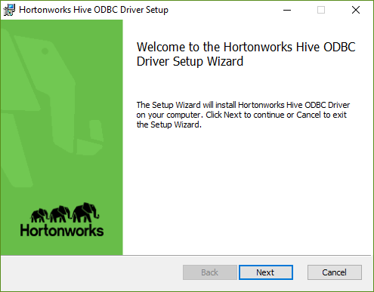

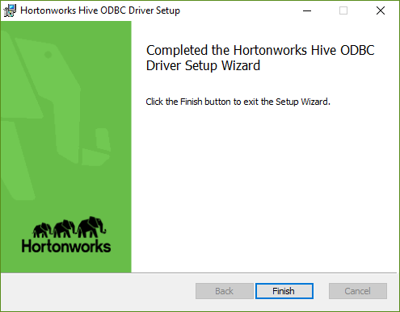

* Add New Connection as directed.

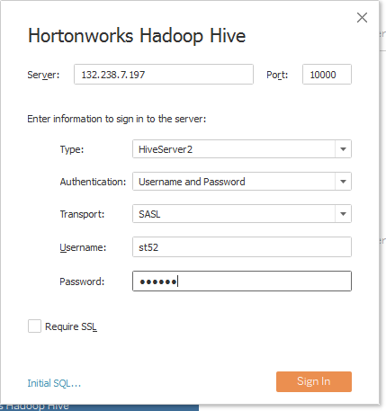

* Now use the same database that we have created, st52_tableau
* Add on use the same table Hospital

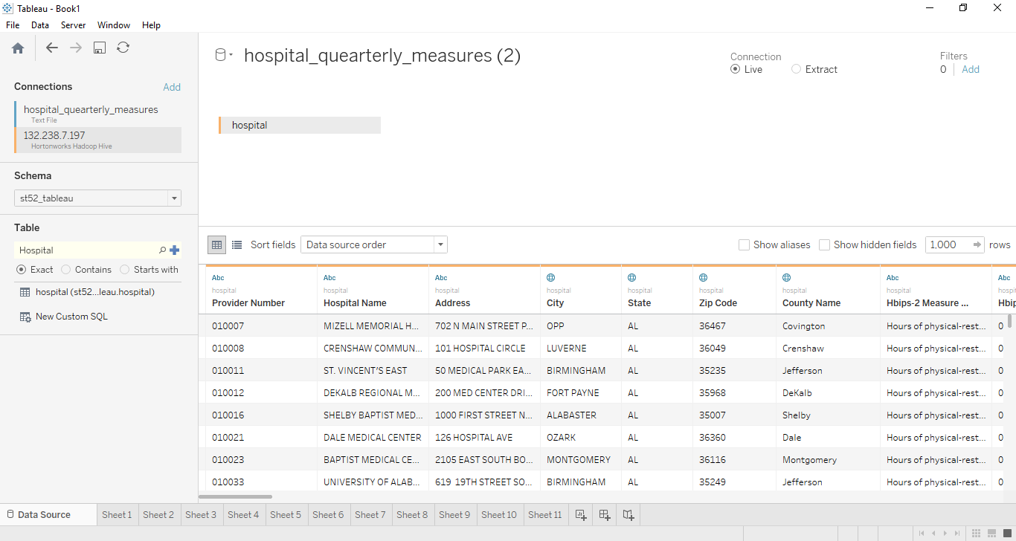

* Number of hospitals per state.

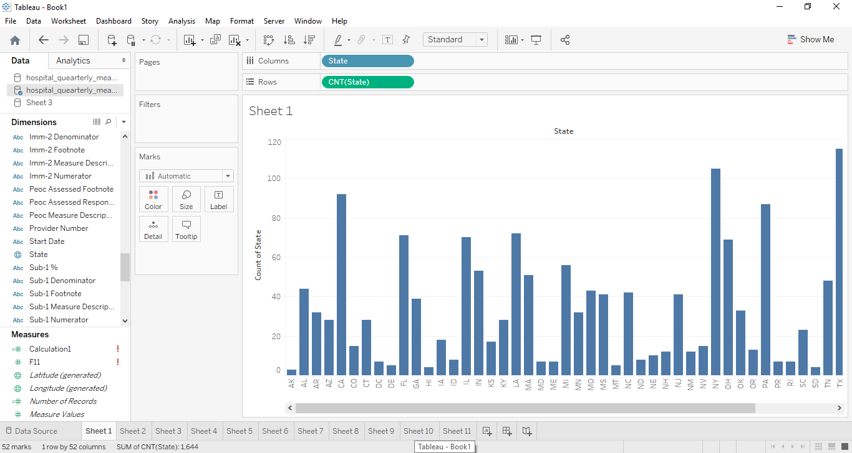

* Top 10 states with the largest number of hospitals.
* To do so we have to add filter for State.

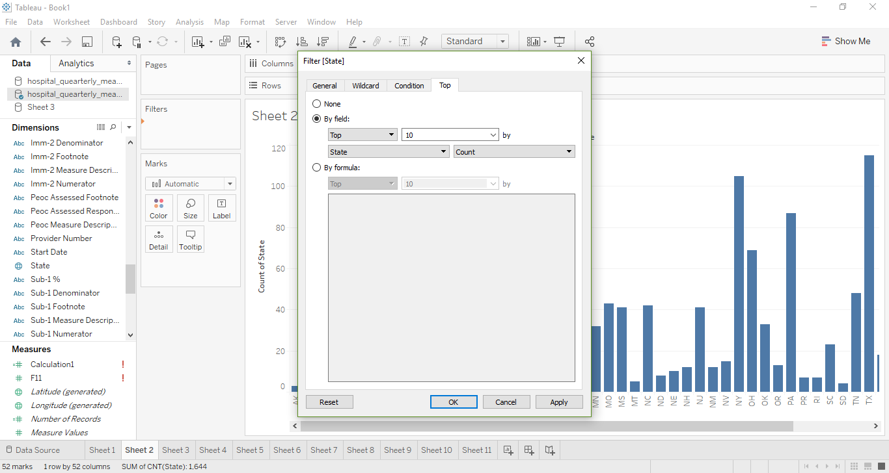

* Same as above with smallest number of hospitals.

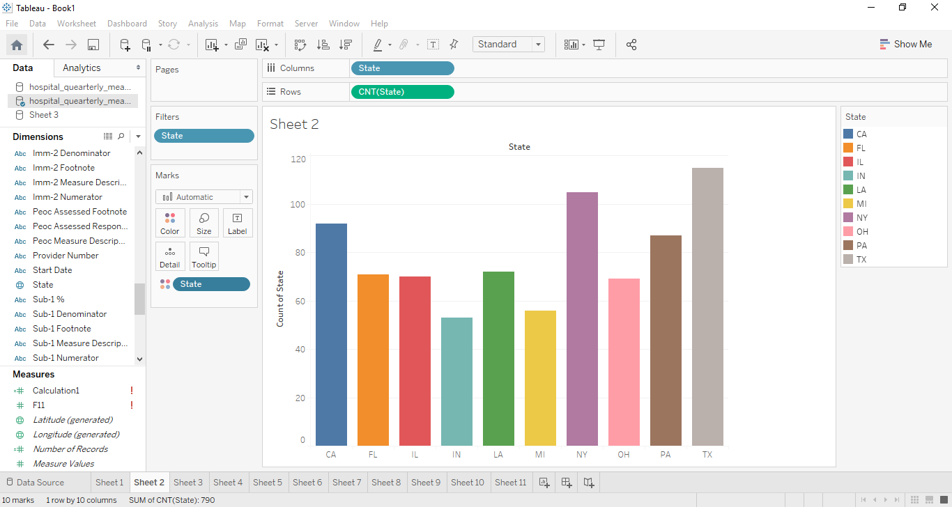

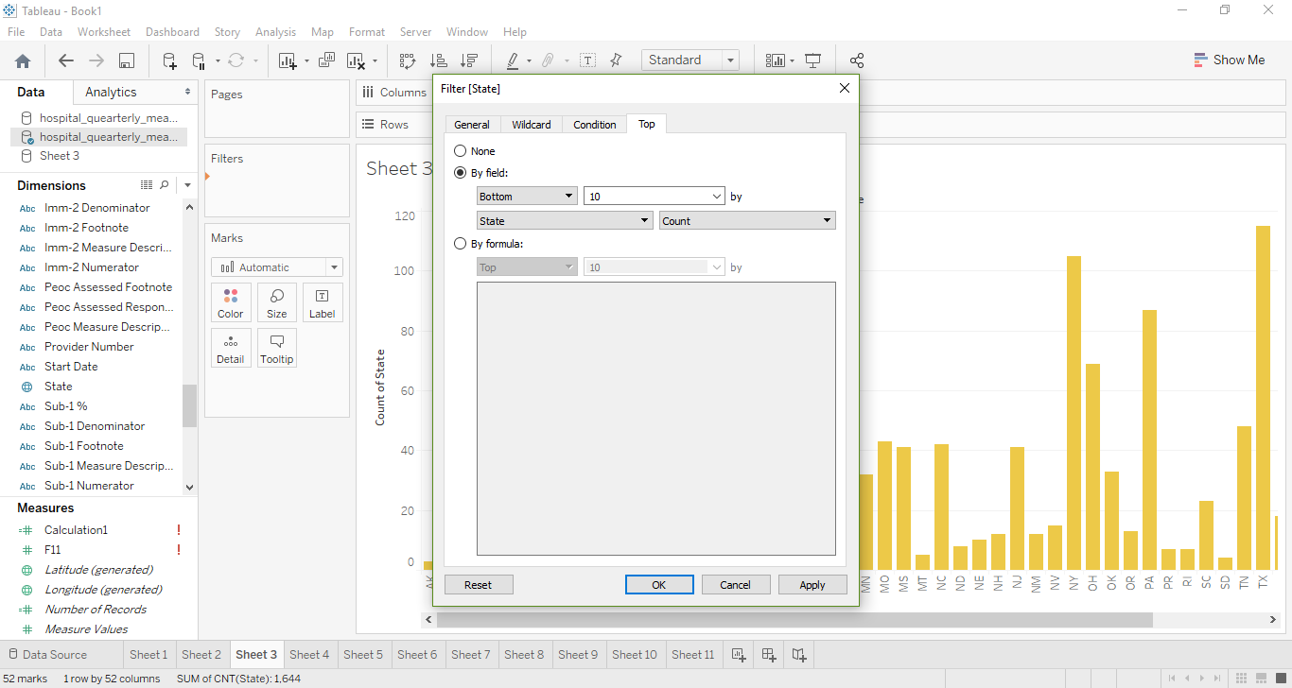

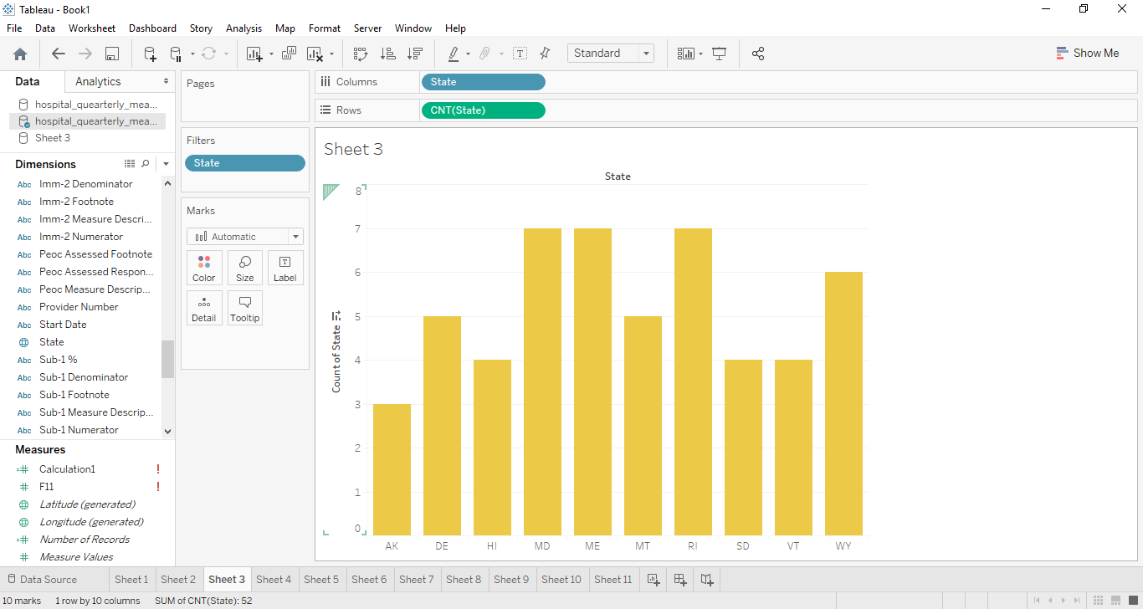

* Number of hospitals per city/state

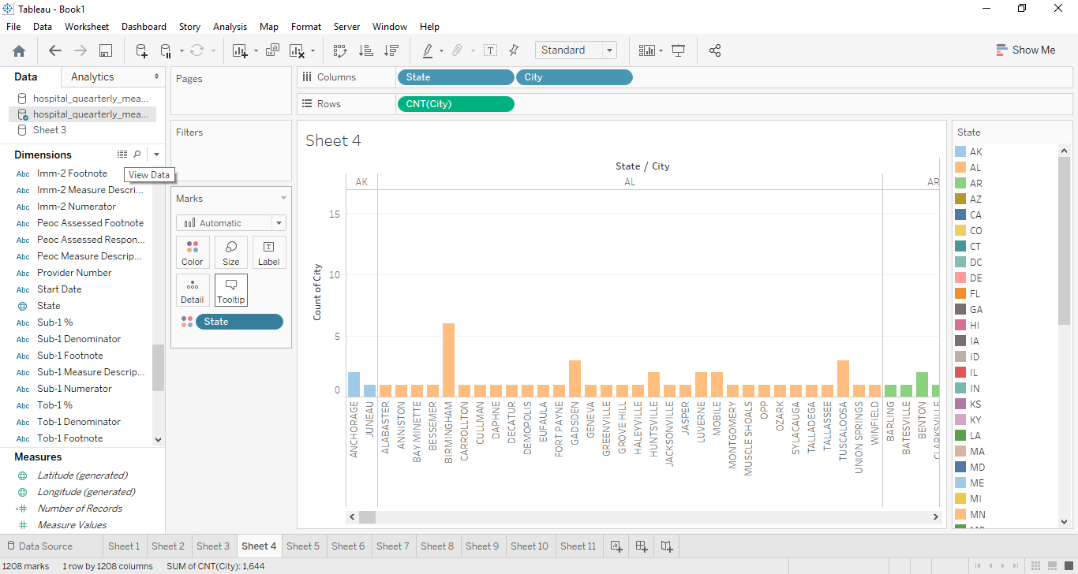

* Top 10 city/state combinations with the largest amount of hospitals

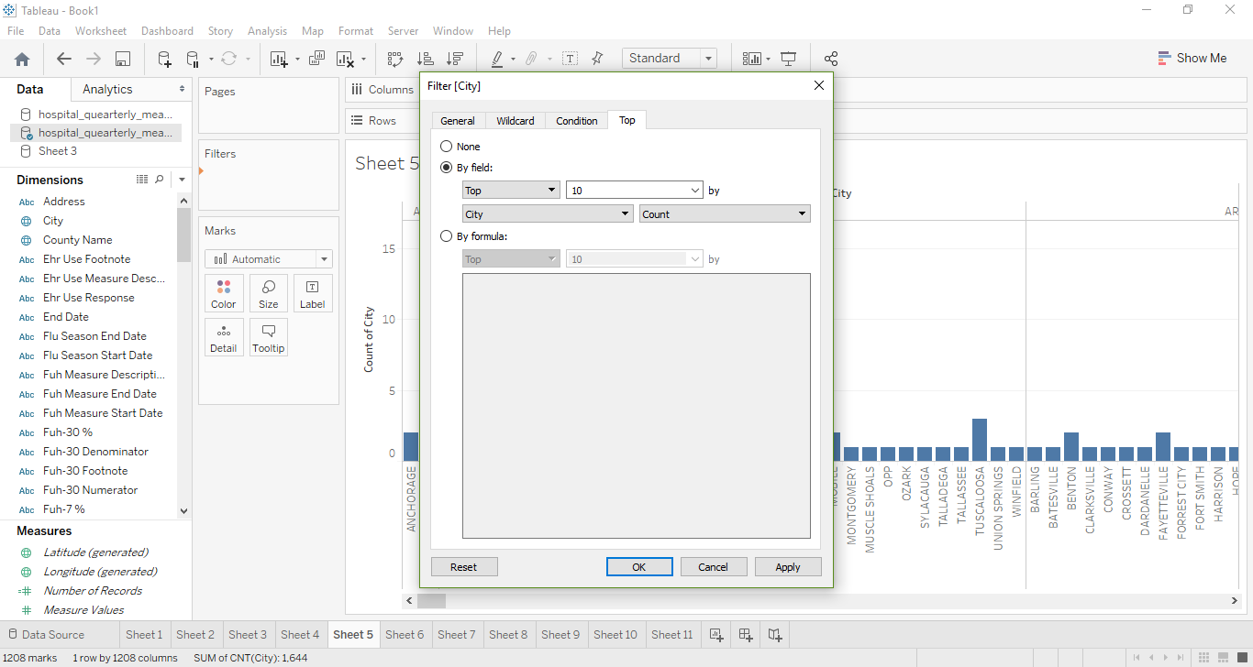

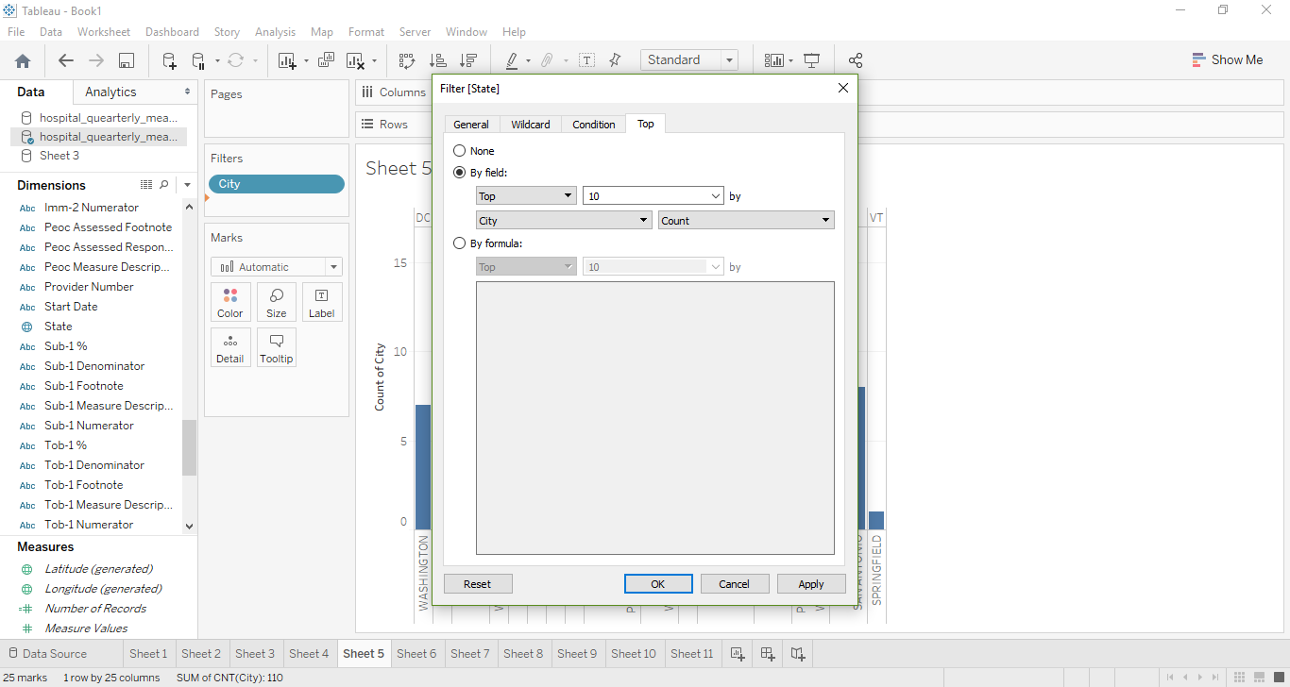

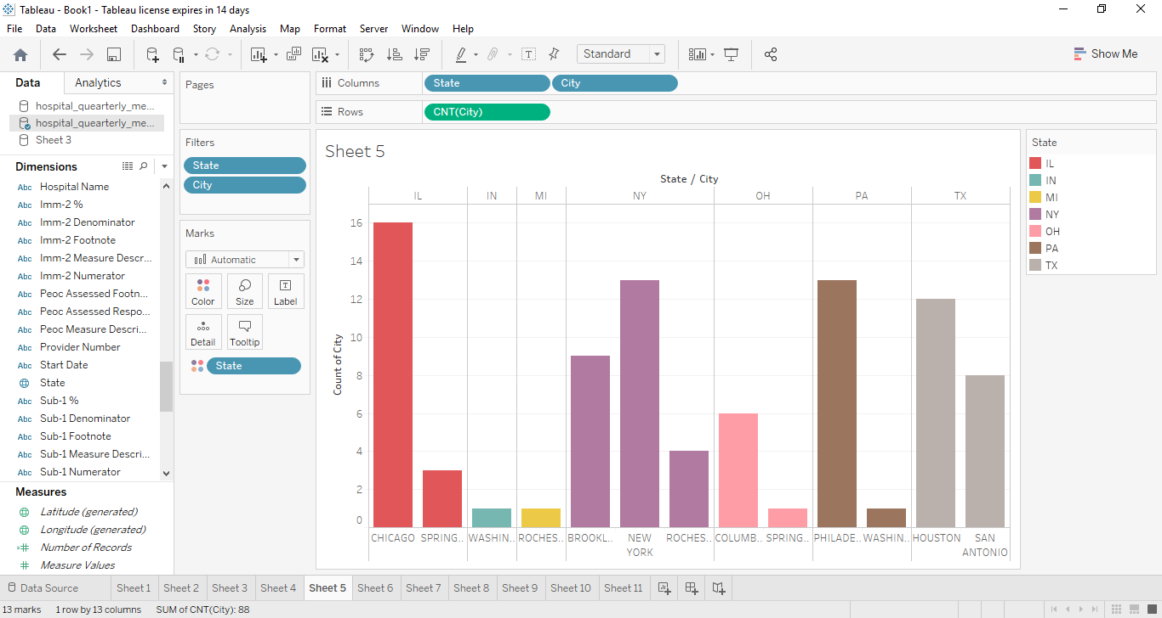

* Same as above with smallest number of hospitals.

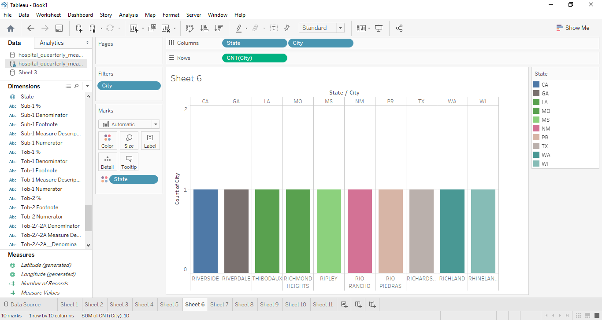

* Number of hospitals per Zip.

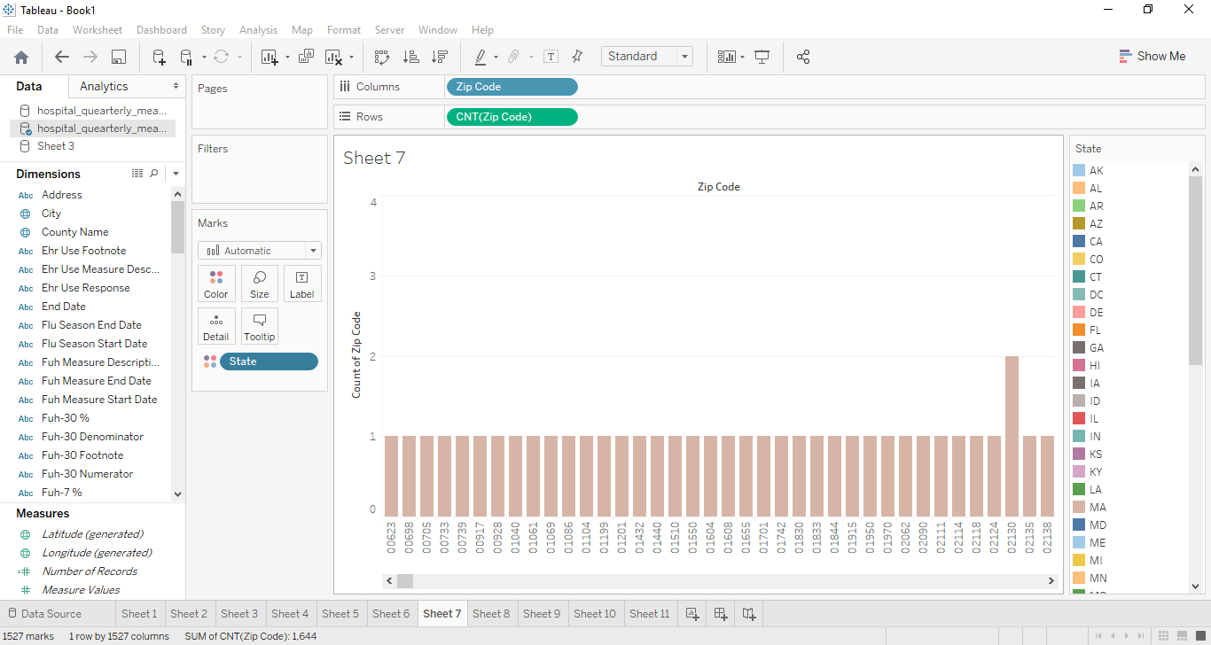

* Top 10 zip codes with the largest number of hospitals.

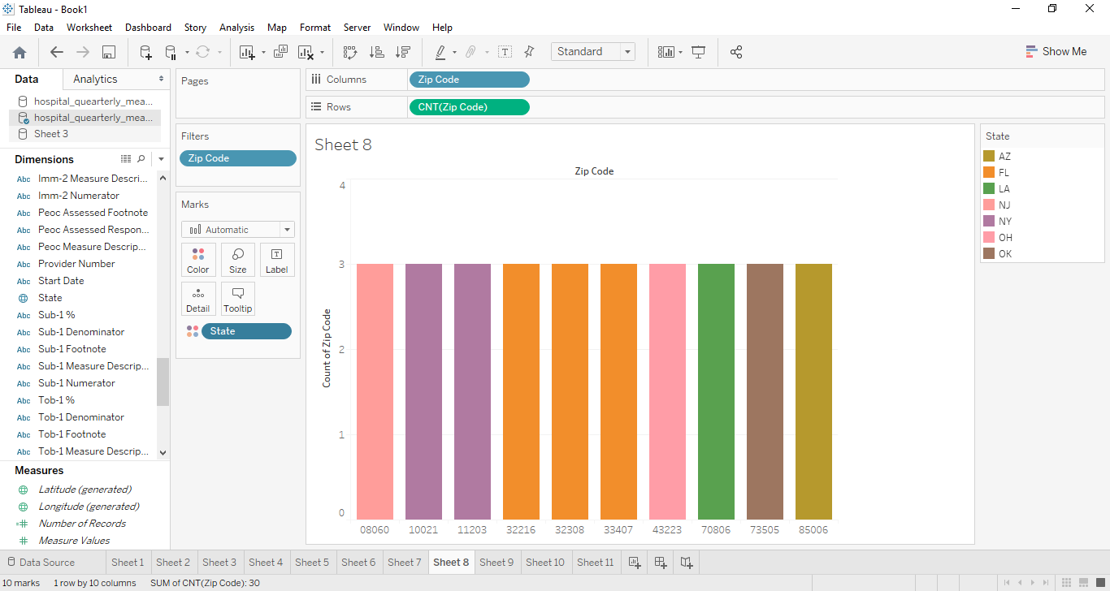

* Same as above with smallest number of hospitals.

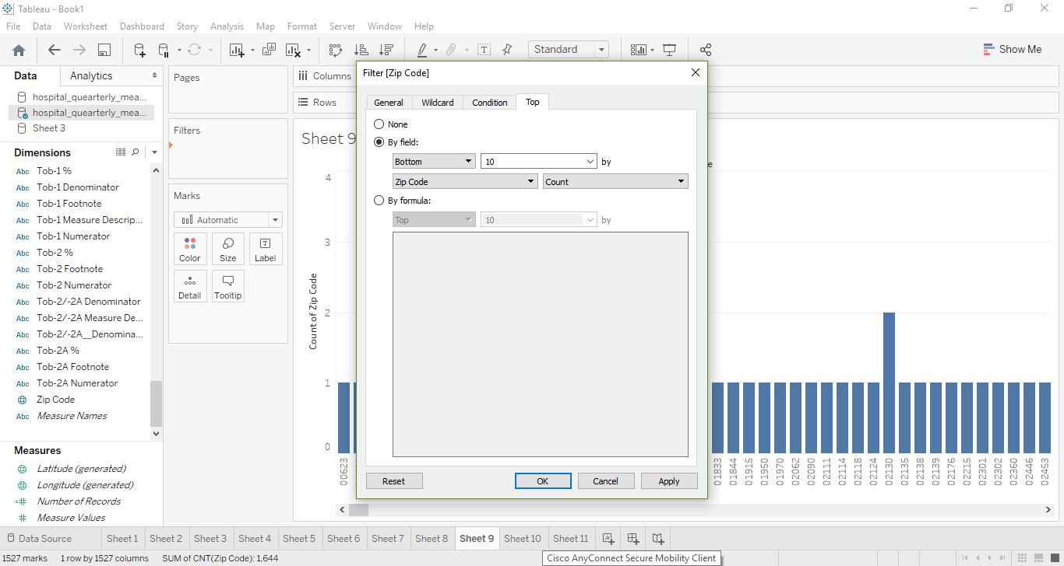

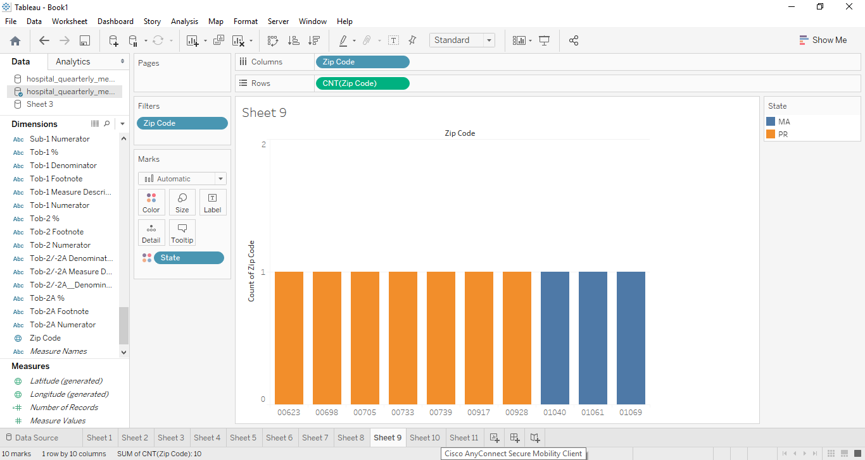

* 1. Build a bar chart showing hospitals and their corresponding values from column

HBIPS-2_Overall_Den.

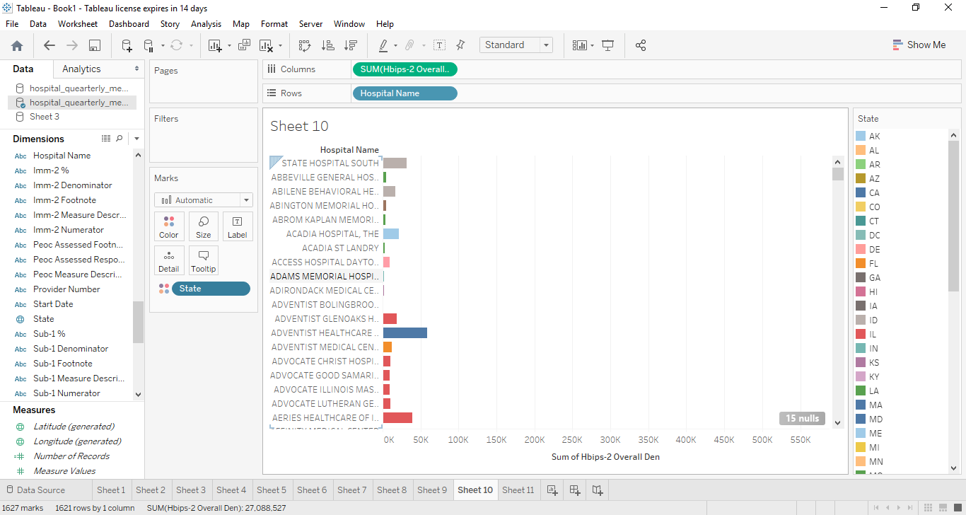

* Allow filtering by the first letter of a hospital name. Use an appropriate control(s).

